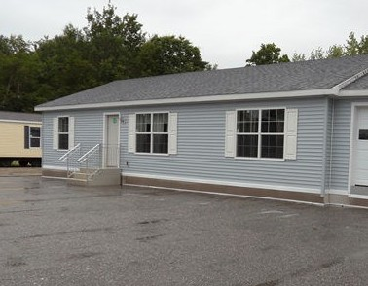In the name of Allah,
Most Gracious, Most Merciful

Islamic Society
of
Greater Augusta

12 Spruce St. Suite 6

Augusta, ME 04330

26’ x 48’ Modular (1248 sq. ft.)
Masjid Fundraiser
Al hamdol Illah
By the Grace of Allah, the Mus- lim community of the greater Augusta, Maine area has purchased six acres of land on which we intend to build a small Masjid. It is located about one mile from the center of the city and is a one minute walk from the middle/high school. It is located on a dead end street that has ample on street parking. The land is large enough to build a small building and parking lot with plenty of room for future expansion.
To date we have raised over
$95,000 toward the goal of demolish- ing some existing structures and build- ing a 1200 sq. ft. building, a parking lot, and a septic system. The estimated total we will need will be approximate- ly $155,000. This leaves a balance of nearly $60,000 left to raise. With the help of Allah and your financial contri- bution we intend to start building be- fore the end of summer.

For questions or comments contact: Jamel at 207 - 485 - 5976
or at OneAllah@hotmail.com
Donation Form

Name: Address: City: State: Zip_ Email: Phone:
Method of Donation

Donation Amount $_ [ ]Cash
[ ]Check

[ ]Paypal

[ ]Money Order

[ ]Bank Transfer

At PayPal.com or at GoISGA.org

Make checks payable to
Islamic Society of Greater Augusta

